  - System Analysis, Design & Testing | Stock ordering project

Project Summary
Nathan Jason Doyle

Intro
I’m going to design a system to help streamline the stock ordering process for a petrol station

Who will use it
The manager will use this system to review and order stock.
Key members of staff will use it to update stock when orders arrive.
How it will work
The system will continuously monitor stock levels by comparing what has come in vs what has been sold at the tills. The system will be able make an order when stock falls below a certain threshold set my the manager, through one button press. Employees can mark orders as arrived and log any discrepancies between the amount ordered and the amount that arrived. The system will then update the stock based on what arrived.
Benefits
This system will help the petrol station run at maximum efficiency. It will prevent the shop from running out of stock for certain items, thus increasing sales and customer satisfaction. Another benefit will be employee satisfaction, as running out of stock can be frustrating for employees and the ability to easily view stock levels will make the employees feel they have a say and added responsibility. It will prevent waste as it will stop the shop from ordering too many perishable items which may not sell before the BB date. It will also allow the manager to spend more time managing other aspects of the shop rather than doing stock takes and orders. Lastly it will provide useful sales data for the manager to help make the shop more profitable using data.

System Analysis, Design & Testing | Stock ordering project
User stories
Nathan Jason Doyle

Story 1
Fields | Detail
Story Identifier | S0S001
Story name | Order all low stock
Description | As a station manager I need the system to help me quickly identify and order all items that we are currently in low supply of
Confirmation | -Functional: Can the system accurately calculate the required quantity based on the reorder level?  -Functional: Can the system accurately order products from their respective supplier  -Non-Functional-performance: Does the order generation take less than 10 seconds?  -Non-functional-security: Are all submitted orders logged with a manager timestamp and ID for audit purposes?
System Analysis, Design & Testing | Stock ordering project
User stories
Nathan Jason Doyle

Story 2
Fields | Detail
Story Identifier | S0S002
Story name | Register Delivery
Description | As a staff member/ manager I need to be able to register the items and quantities that arrive in the delivery, so that the current stock levels are updated to be accurate.
Confirmation | -Functional: Can I use the system quickly to find a previously placed order by the supplier name or date?  -Functional: Can I modify the quantity of items received if what arrives is different to what is ordered?  -Non-Functional-usability: Can I do this in as little clicks as possible

System Analysis, Design & Testing | Stock ordering project
User stories
Nathan Jason Doyle

Story 3
Fields | Detail
Story Identifier | S0S003
Story name | Set reorder levels
Description | As a station manager I need to be able to set the threshold for when the system needs to order an item when it is low, and a maximum level so that the system does not over stock on a certain item
Confirmation | -Functional: Can I set a specific number that if stock falls below the system will add the item to the order?  -Non-Functional: Can this be as simple as entering a number when adding a product

System Analysis, Design & Testing | Stock ordering project
User stories
Nathan Jason Doyle

Story 4
Fields | Detail
Story Identifier | S0S004
Story name | Check current stock levels
Description | As a station manager I need to be able to quickly check stock levels for any item so that I can make sure no stock is missing and if a customer asks for something I can see if it’s in stock
Confirmation | -Functional: Can I see all products and their respective stock levels?  -Non-Functional-performance: Does the system load the stock list of 100 items in less than 5 seconds?  -Non-functional-usability: Is the low stock level indicator clearly visible e.g. red text?

System Analysis, Design & Testing | Stock ordering project
User stories
Nathan Jason Doyle

Story 5
Fields | Detail
Story Identifier | S0S005
Story name | Supplier Management
Description | As a station manager I need to be able to add, and remove suppliers so that the ordering process is up-to-date with contact info. I also need to be able to assign a supplier to a specific product so I can know where what items come from and how much they cost.
Confirmation | -Functional: Can I assign a product to a supplier?  -Functional: Can I store the price of the item on the system so I know how much the order will cost?

System Analysis, Design & Testing | Stock ordering project
User stories
Nathan Jason Doyle

Story 6
Fields | Detail
Story Identifier | S0S006
Story name | Role based access
Description | As a user I need the system to hide certain options from me depending on whether I am a staff or a manager
Confirmation | -Functional: Can the manager access everything that they need to  -Functional: Can the staff access everything that they need to, and nothing that they don’t or shouldn’t

System Analysis, Design & Testing | Stock ordering project
Use case scenarios
Nathan Jason Doyle

Use case name: Order all low stock | UniqueID: SOS_UC01
Area: Ordering
Actor(s): Station Manager
Description: The system automatically checks inventory levels and generates an order for all items low in stock, enough to bring it above the reorder level
Triggering Event: An item’s inventory level is recorded as being below it’s reorder point
Trigger type: External Temporal
Steps Performed (Main Path) | Information for Steps
1. | The manager clicks the “Order all low stock” button
2. | System finds all items below their reorder level
3. | System calculates how much to order (x = (reorder level + 1) – current stock)
4. | System displays a breakdown of the details of the order
5. | Manager hits confirm
6. | System places the order
Preconditions: The product must have a defined reorder point, maximum stock level, and a supplier assigned to it.
Postconditions: A new order is created and logged in the system
Assumptions: The system has access to accurate, up-to-date inventory levels.
Requirements met: SOS001(Order all low stock)
Outstanding issues: N/A
Priority: High
Risk: Medium(Risk of inaccurate order if stock data is old).

System Analysis, Design & Testing | Stock ordering project
Use case scenarios
Nathan Jason Doyle

Use case name: Receive Order | UniqueID: SOS_UC02
Area: Inventory
Actor(s): Retail Staff/ Manager
Description: Staff processes a physical delivery, updating the system inventory to reflect the new stock count.
Triggering Event: A physical stock delivery arrives at the petrol station.
Trigger type: External User Input
Steps Performed (Main Path) | Information for Steps
1. | User locates the expected Order in the system.
2. | User marks the order as arrived
3. | Staff confirms the received quantities. If there is a discrepancy, they log it
4. | System updates the Stock on Hand for all received products.
Preconditions: A Purchase Order must have been previously transmitted and be in ‘Pending' status.
Postconditions: The corresponding PO status is updated to 'Arrived'. Inventory levels are updated.
Assumptions: Staff have the authority to update inventory levels.
Requirements met: SOS002 (Book-In Delivery)
Outstanding issues: N/A
Priority: High
Risk: Low (Staff training mitigates data entry errors).

System Analysis, Design & Testing | Stock ordering project
Use case scenarios
Nathan Jason Doyle

Use case name: Flag stock discrepencies | UniqueID: SOS_UC03
Area: Inventory / Quality Control
Actor(s): Retail Staff/ Manager
Description: Allows staff to record variances (shortages or overages) between the ordered quantity and the quantity physically delivered.
Triggering Event: Staff enters a received quantity that does not match the ordered quantity during the Receive Order process.
Trigger type: Internal Condition
Steps Performed (Main Path) | Information for Steps
1. | User detects a variance during step 3 of Receive Order.
2. | User clicks “Add discrepancy” button
3. | User enters the discrepancy reason and submits the record.
4. | System logs the discrepancy and updates the stock to reflect the discrepancy.
Preconditions: Must be initiated by user.
Postconditions: A Discrepancy Record is created. Inventory levels are updated based on the actual quantity received
Assumptions: User can accurately count delivered goods.
Requirements met: SOS002 (Book-In Delivery)
Outstanding issues: N/A
Priority: Medium
Risk: Low

System Analysis, Design & Testing | Stock ordering project
Use case scenarios
Nathan Jason Doyle

Use case name: Low Stock Indicator | UniqueID: SOS_UC04
Area: Reporting / Inventory
Actor(s): Station Manager/ Staff
Description: System makes it simple to identify stock currently below reorder level
Triggering Event: User views inventory
Trigger type: External User views inventory
Steps Performed (Main Path) | Information for Steps
1. | User presses “View inventory” button
2. | System queries the database for all items.
3. | System formats the data into a table, displaying all normal stock with black text, and all low stock items with red text
4. | User can quickly tell what stock is low
Preconditions: The user must know that red means low stock
Postconditions: A manager can then order stock based off this info
Assumptions: System can handle large data sets and generate the table quickly.
Requirements met: SOS004 (Check Current Stock)
Outstanding issues: N/A
Priority: Medium
Risk: Low

System Analysis, Design & Testing | Stock ordering project
Test Cases
Nathan Jason Doyle

Case 1
Order all low stock (Order creation)
Field | Detail
Name | TC-01: Verify system order calculation for low stock 'Coca-Cola 500ml
Requirements | SOS001 (Order all low stock): System must automatically make an order for stock that is low.
Preconditions | 1. The product 'Coca-Cola 500ml' has a defined Reorder Point of 24 units and Max Level of 72 units.  2. Current stock level is manually adjusted to 15 units.
Steps | 1. Log into the system as Station Manager.  2. Click the "Order all low stock" button on the Dashboard.  3. Navigate to the "Manage Orders" screen.  4. Find the newly created order.
Expected Results | 1. A popup appears showing the details of the order “Coca-Cola 500ml” 10 units ((24+1) – 15)  2. A new order appears in the list.

System Analysis, Design & Testing | Stock ordering project
Test Cases
Nathan Jason Doyle

Case 2
Register delivery (Standard)
Field | Detail
Name | TC-02: Verify inventory update upon receiving full delivery for PO-102
Requirements | SOS002 (Register Delivery): Register items and quantities so current stock levels are updated.
Preconditions | PO-102 is in ‘Pending' status. Physical delivery of 12 units of 'Coca-Cola 500ml' has arrived.
Steps | 1. Log in as Retail Staff.  2. Navigate to the "Manage orders" screen.  3.Select the order.  4. Click in the "Mark as arrived" button.  6. Click "Confirm".
Expected Results | 1. The system marks PO-102 status as ‘Arrived’.

System Analysis, Design & Testing | Stock ordering project
Test Cases
Nathan Jason Doyle

Case 3
Flag Stock Discrepancy
Field | Detail
Name | TC-03: Verify variance logging when receiving 40 units of 'Walkers Crisps' instead of 50
Requirements | SOS002 (Register Delivery): Modify quantity if what arrives is different to what is ordered.
Preconditions | Order exists manage orders screen,. 50 units of 'Walkers Crisps'. Status is 'Arrived'.
Steps | 1. Open the "Manage orders" screen.  2. Select relevant order  3. Click “Add discrepancy”  4. Enter the amount received and the reason  5. Click "Submit".
Expected Results | 1. Verify 'Walkers Crisps' inventory increases by 40 (not 50).  2. Verify a Discrepancy Record is created linked to the order.

System Analysis, Design & Testing | Stock ordering project
Database tables
Nathan Jason Doyle

Discrepancy reports
Data
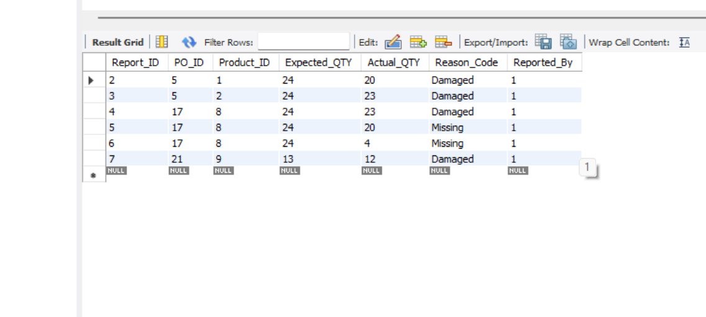
Structure
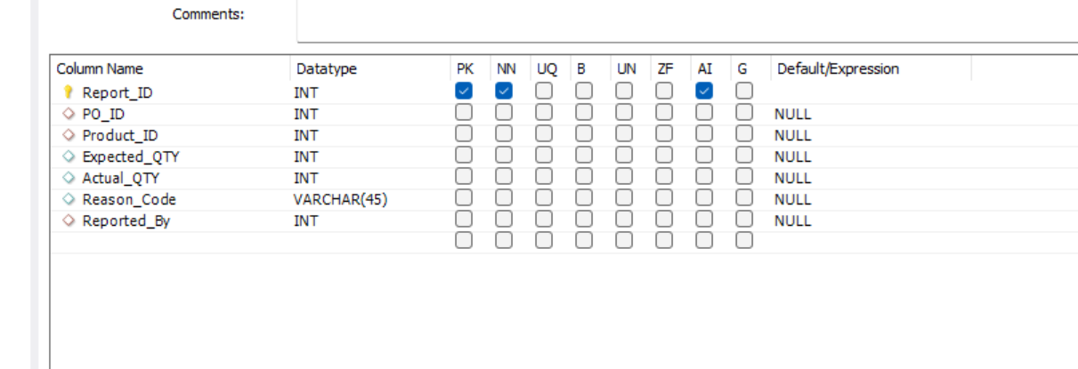

System Analysis, Design & Testing | Stock ordering project
Database tables
Nathan Jason Doyle

Order items
Data
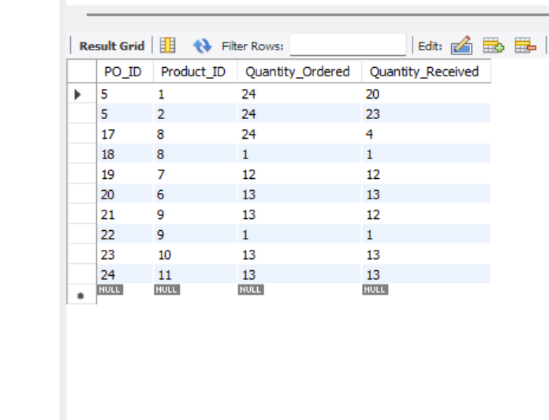
Structure
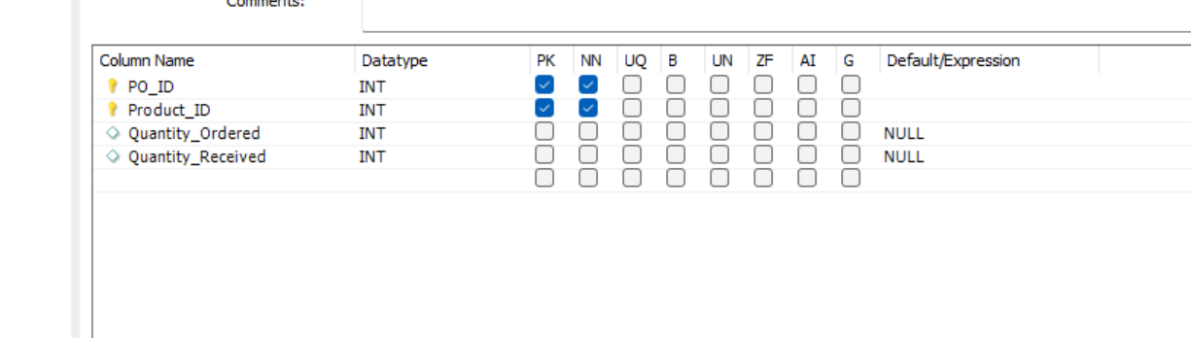

System Analysis, Design & Testing | Stock ordering project
Database tables
Nathan Jason Doyle

Products
Data
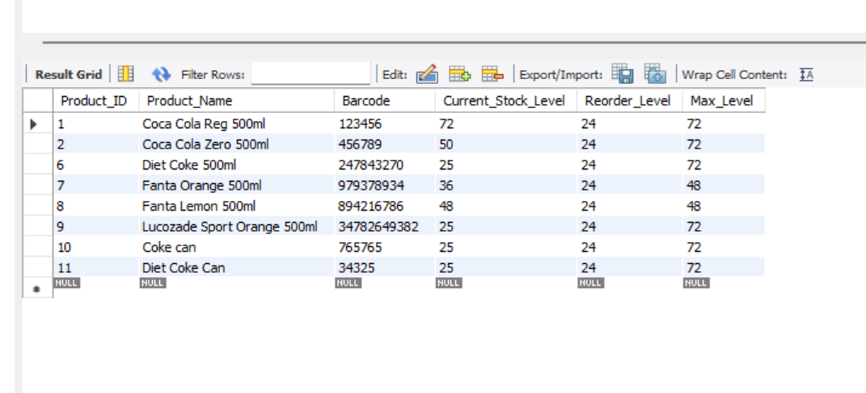
Structure
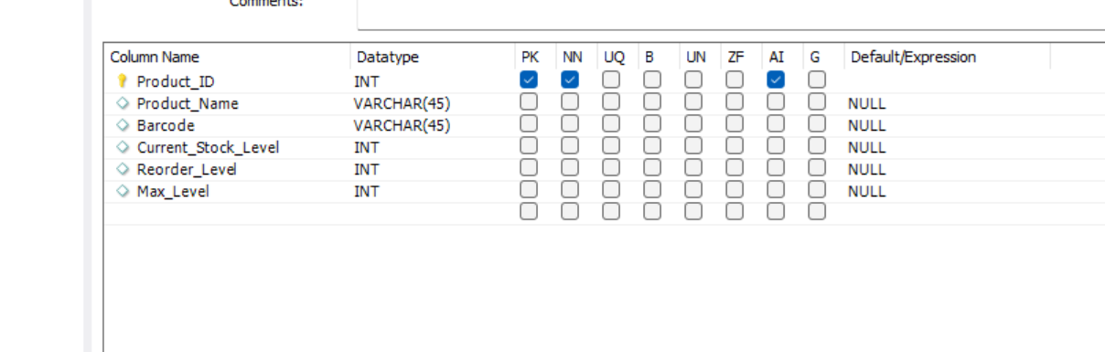

System Analysis, Design & Testing | Stock ordering project
Database tables
Nathan Jason Doyle

Purchase orders
Data
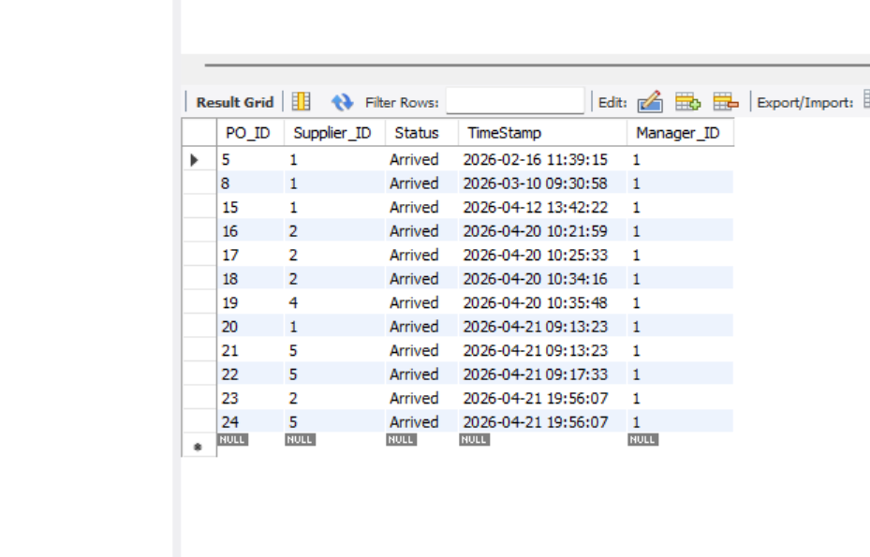
Structure
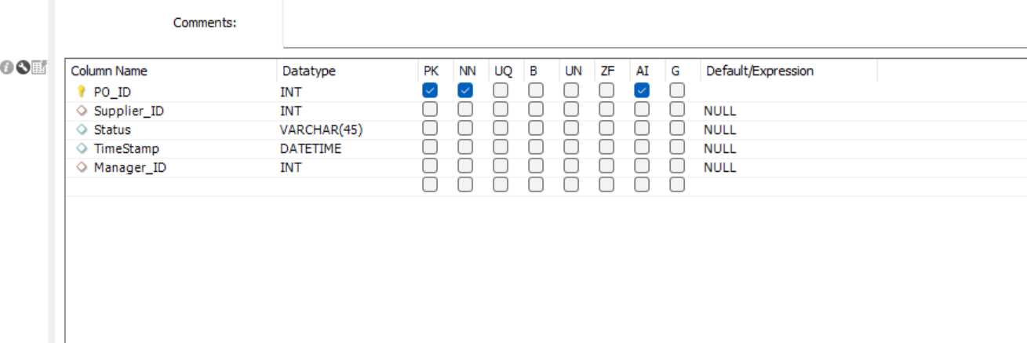

System Analysis, Design & Testing | Stock ordering project
Database tables
Nathan Jason Doyle

Supplier Products
Data
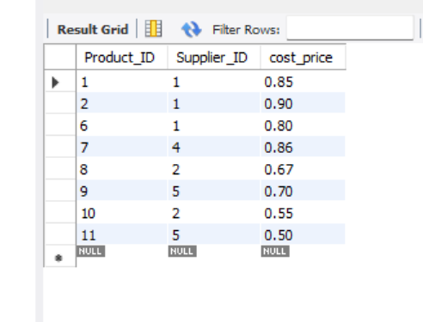

Structure
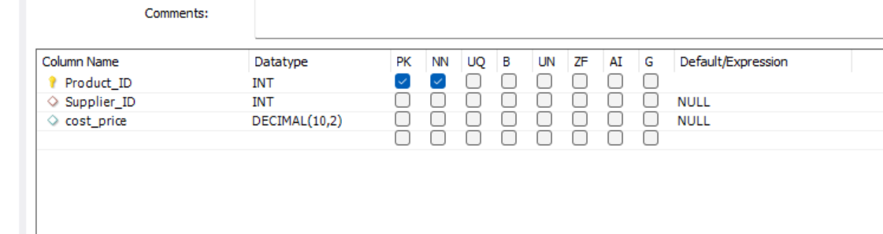

System Analysis, Design & Testing | Stock ordering project
Database tables
Nathan Jason Doyle

Suppliers
Data
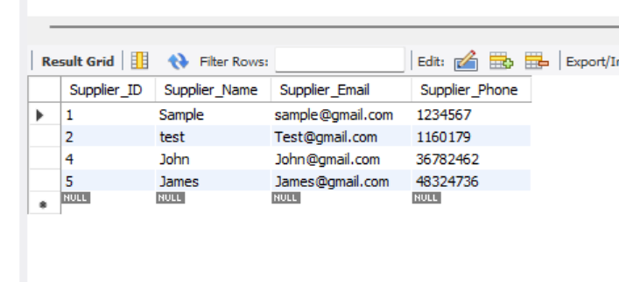

Structure
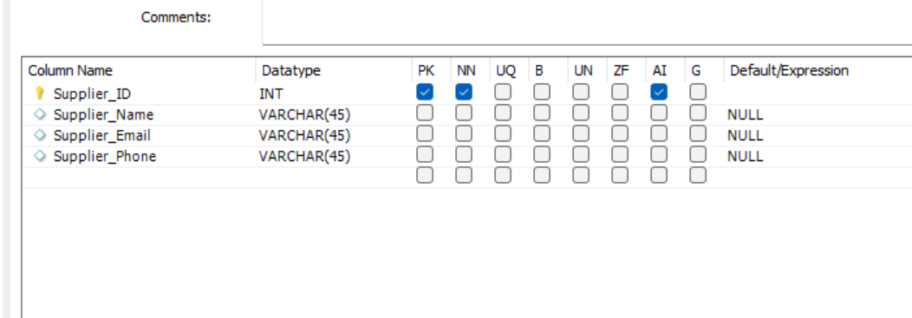

System Analysis, Design & Testing | Stock ordering project
Database tables
Nathan Jason Doyle

Users
Data
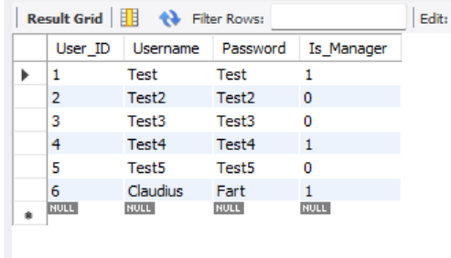

Structure
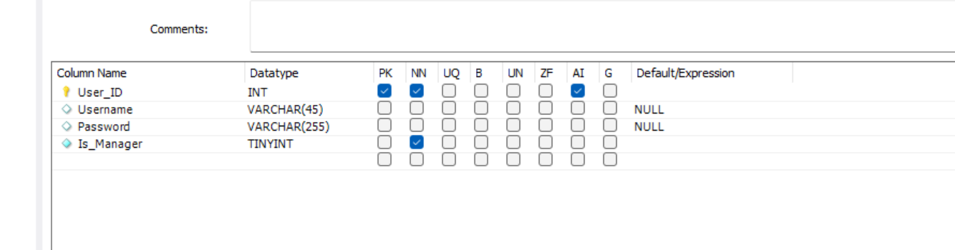

System Analysis, Design & Testing | Stock ordering project
ER Diagram
Nathan Jason Doyle

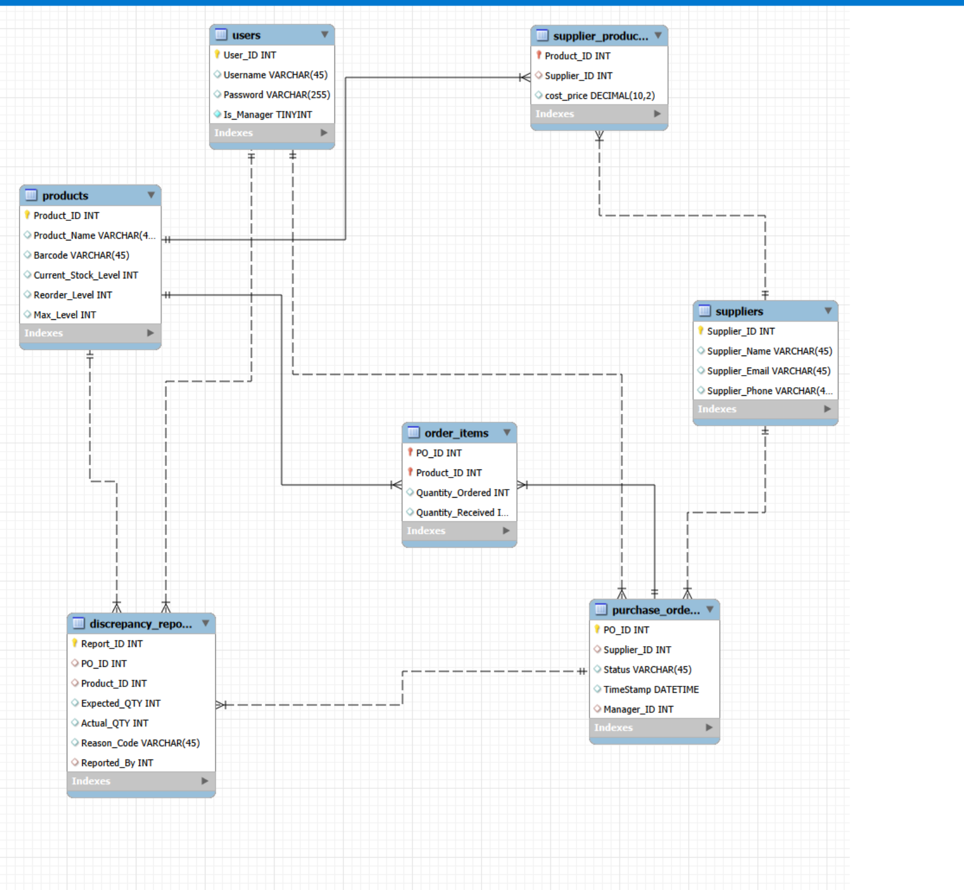

System Analysis, Design & Testing | Stock ordering project
Code snippets
Nathan Jason Doyle

Snippet 1
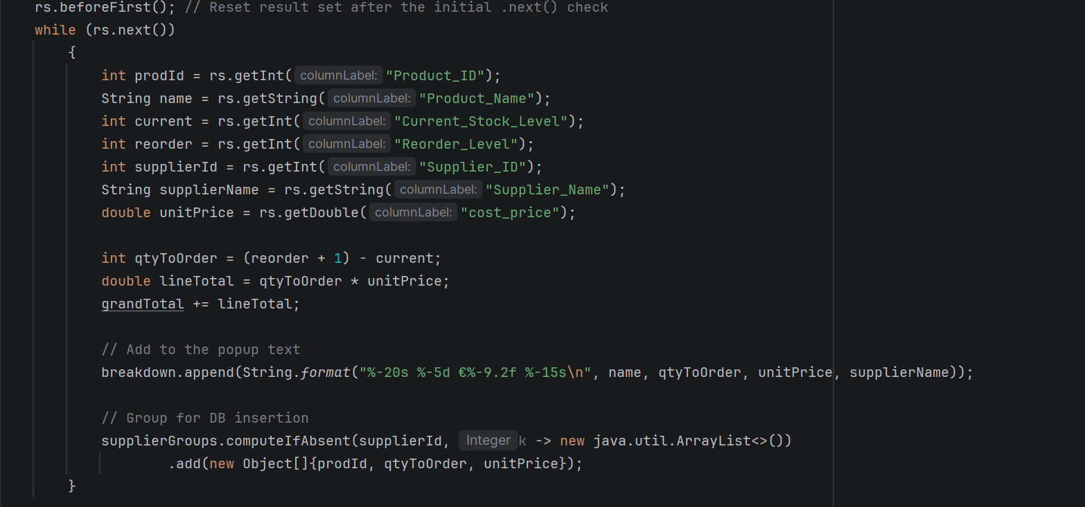
This is some logic behind the “Order all low stock” button.
I find this snippet interesting because it implements a simple rule to ensure that we order just enough stock to meet the minimum, but no too much that we become over stocked. The system semi automates the ordering process by ordering just enough and if the manager decides we need more, extra can be ordered manually.
Another reason that I like it, is I used a map to group products by suppliers

System Analysis, Design & Testing | Stock ordering project
Code snippets
Nathan Jason Doyle

Snippet 2
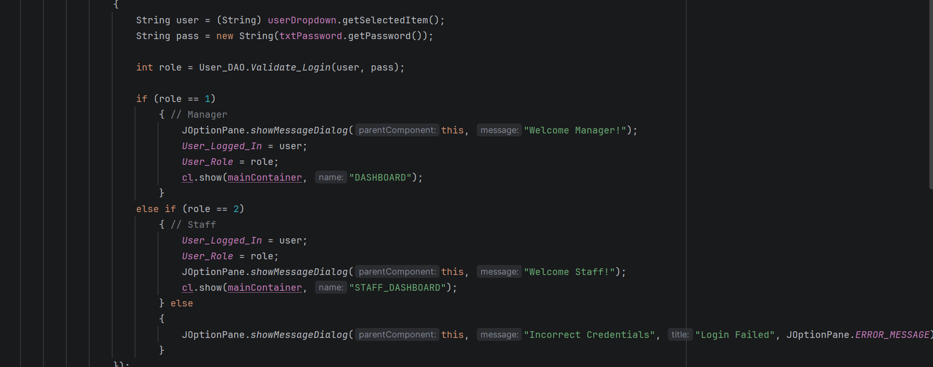
This is what decides what dashboard to give the user based on their role
I like this snippet, mainly because of it’s simplicity, just a simple 1=manager, 2= staff, anything else = failed login
Despite how simple it is, it’s a super important security feature that prevents access to certain features unless you are a manager, by giving you a completely different dashboard.

System Analysis, Design & Testing | Stock ordering project
Code snippets
Nathan Jason Doyle

Snippet 3
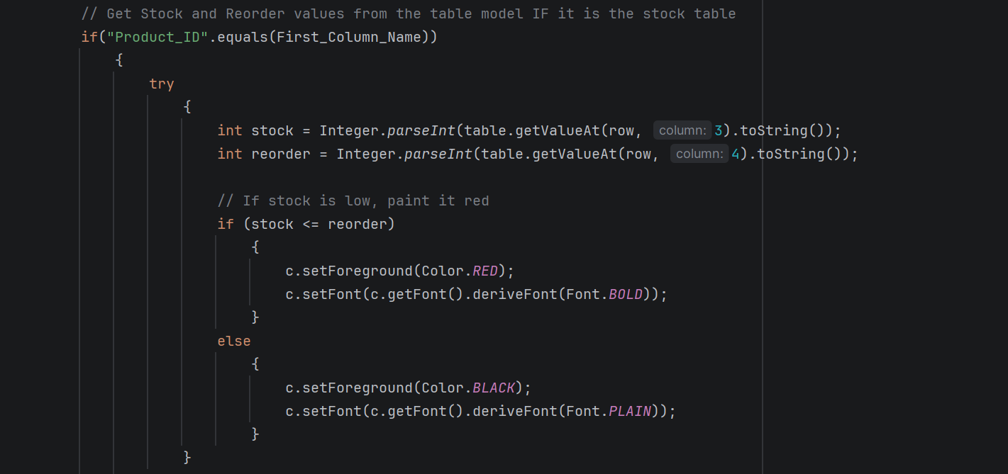
This is what colours the low stock items red in the “View Inventory” screen.
I love this snippet, because it is one of the first interesting pieces of GUI I did for this project and was super excited when I seen it work and realised how useful it is to have the low stock highlighted in red.

